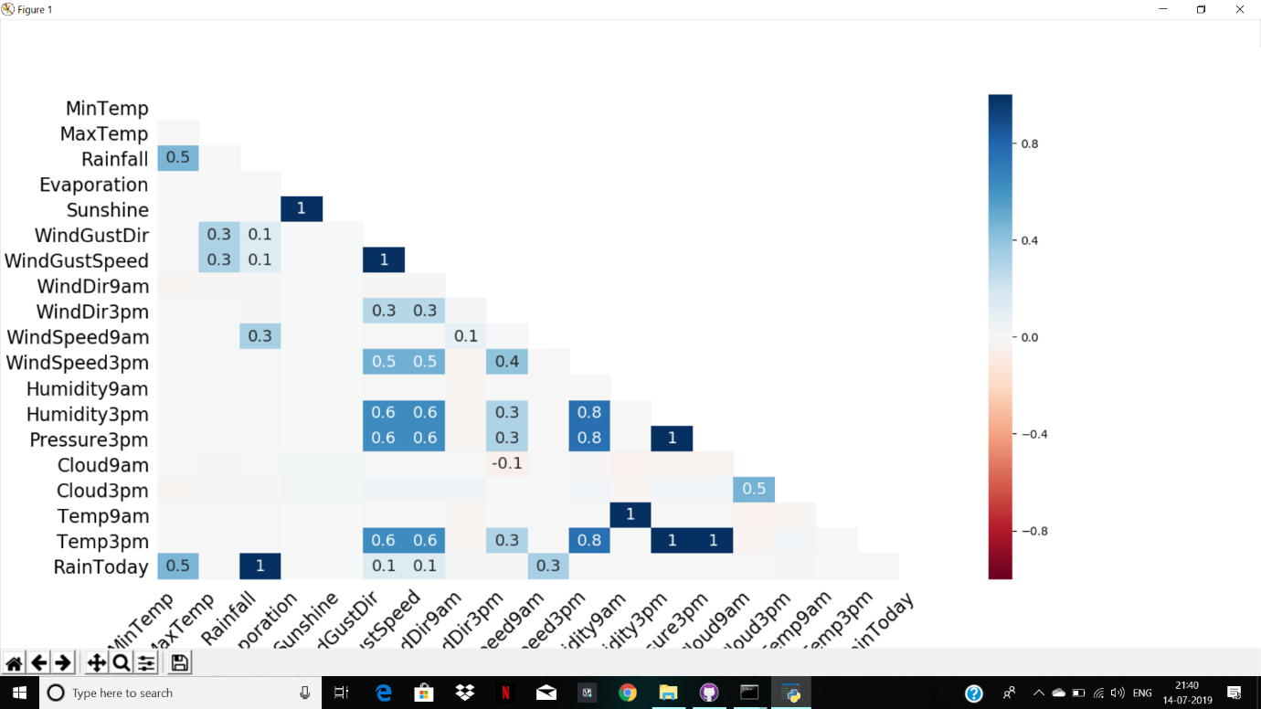Heat Map:

Heat map showing the relation between the given variables. The command I used to obtain this is:

import missingno as mnso

col_name=['Date', 'Location', 'MinTemp', 'MaxTemp', 'Rainfall', 'Evaporation', 'Sunshine', 'WindGustDir', 'WindGustSpeed', 'WindDir9am', 'WindDir3pm', 'WindSpeed9am', 'WindSpeed3pm', 'Humidity9am', 'Humidity3pm', 'Pressure9am', 'Pressure3pm', 'Cloud9am', 'Cloud3pm', 'Temp9am', 'Temp3pm', 'RainToday', 'RISK_MM', 'RainTomorrow']

we_pd=pd.read_csv("C:/Users/Admin/machine_learning/summer_io/csv_files/alb.csv",header=None,names=col_name)

s=mnso.heatmap(we_pd)

plt.show()